**JYS Consultants-PosiPower Concepts, Inc.**

**5327 Knotting Woods Dr., Westerville, Ohio 43081**

**Phone: 614-775-6069**

**jysposipower@gmail.com** [**www.posipowerconcepts.com**](http://www.posipowerconcepts.com/)

**PosiPower Workshops for Early Head Start/Head Start Programs**



***"Where all elements of training begin with self"***

1. ***PosiPower Leadership Training for Head Start - (NEW)***
2. ***“Why? Why? Why?”- Teach Science to Little Kids***
3. ***ERSEA: Learn Best Practice for EHS/HS***
4. ***PosiPower Policy Council Meeting -***
5. ***PosiPower Head Start Leadership Governance Training - Federal Policy and Guidelines -***
6. ***Be a PosiTeacher in Your Classroom***
7. ***What to Do When Little Kids Won’t Listen – Classroom Management Skills***
8. ***5+5 Ways to Teach Math in Head Start***
9. ***“I can READ” – Early Learning Literacy***
10. ***Help Kids Deal With Anger***
11. ***Co-Teachers Working Together as a Team***
12. ***PosiPower Ways to Effectively Work With Parents***
13. ***Working in Teams – Teachers, Bus Drivers, Managers, etc…***
14. ***Time and Stress Management for Teachers and Staff***
15. ***Hire and Retain the Best Teachers***
16. ***PosiPower eLearning and eTeaching******With Technology***
17. ***Coaching the Best Out of Your Teachers and Staff – For Management***
18. ***Celebrate Diversity in Your Classroom***
19. ***Balance Work and Family & Be Positive in Both***
20. ***Head Start Teachers Model Respect for Diverse Families***
21. ***Recognizing Physical, Sexual, Emotional Abuse, and Child Neglect ( 3-part series)***

**Jordana Y. Shakoor, M.Ed., President**

**Office - 614-775-6069**

**Email: jysposipower@gmail.com**

**Website:** [**www.posipowerconcepts.com**](http://www.posipowerconcepts.com/)

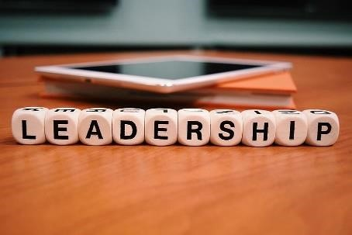

# 1. PosiPower Leadership Training for Head Start

Head Start leadership has a profound opportunity to plan for a future where the largest percentage of children entering Early Head Start/Head Start are Black and brown children from various ethnic groups. Head Start has withstood the test of time and is a successful poverty program that was established in 1965 by President Lyndon B. Johnson. This near 60 years of success is because of dedicated leadership. In this course, Head Start leaders will discuss leadership skills required in the following components of its program: the governing body/Tribal Council (i.e., legal and fiscal responsibilities), Policy Council/parent committees (i.e., set program direction), and management staff (i.e., day-to-day operations). These entities must work seamlessly together to provide leadership and strategically planned direction. Our goals and objective in this course are to provide strategies that will enhance outstanding leadership for the future of Head Start. In this presentation Head Start participants will learn:

*Why maintain a positive self-image?

*The attributes of positive leadership.

*The benefits of working effectively with the Tribal Council Policy Council, parents, and staff?

*That their staff will benefit from effective leadership.

*What a positive future looks like with a diverse Head Start

Various leadership styles

* The bricks of an outstanding Head Start leadership program.
* 15 PosiPower Ways to work Effectively with parents and increase recruitment/enrollment.
* 20 PosiPower Ways that all children benefit from outstanding Head Start Programs.

# 2. "Why? Why? Why?": Teach Science to Little Kids

"Do you ever just wonder about stuff? Well young kids this do all the time. Their questions are nonstop. Why? Why? Why? How does that work? What makes it stay up? What keeps it solid? Why did it melt? Why did that slimy stuff turn blue or is that greenish blue? Is it crawly? Does it have legs? Does it have babies? How many eggs are in that mud? Will it bite me? Does it rust? Will it multiply? Is it dangerous? ***What is poop?*** Why does it smell like horse. *poop*? Yes, they are serious. Kids will ask about anything. What is *it*? How do astronauts pee in space? Someone must ponder with a frown or smile and ask these questions. Who is going to answer their questions? YOU can! In this course, PosiTeachers learn:

* Why be positive?
* PosiTeachers know that science matters.
* Why develop a positive growth-mindset about science
* Why science helps kids to have life skills.
* Why do children need critical thinking skills?
* Why foster a love for science in children
* Why is it important to respond to "Why...?"
* PosiTeachers will learn 20 science activities.
* PosiTeachers learn why it is important to teach science to preschool and Head Start

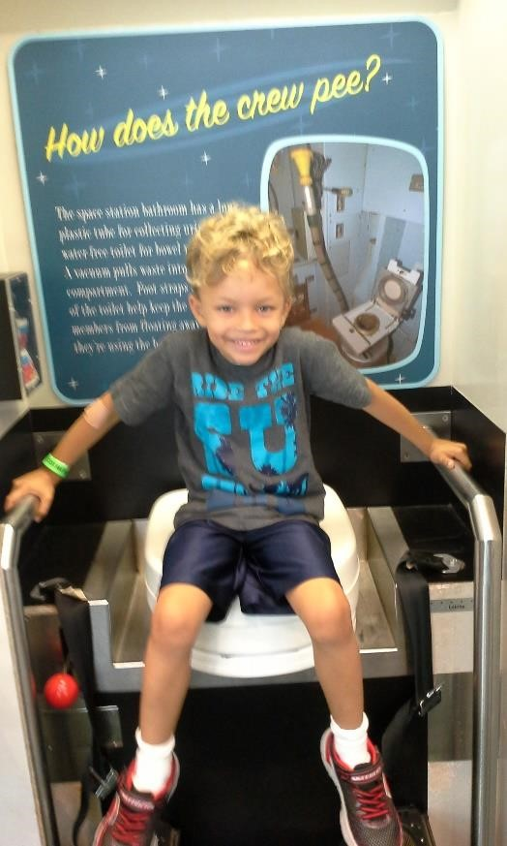

# 3.ERSEA – Learn Best Practice for EHS/HS & PosiPower Policy Council Meeting

Head Start is constantly transforming the way it operates to meet increasingly higher standards. Therefore, learning best practice for ERSEA is essential for Early Head Start/Head Start programs. It is important that staff remain diligent, focused, and committed to outstanding best practice. ERSEA has 5 components: eligibility, recruitment, selection, enrollment and attendance. Each component is vital in how to make determination and ensure that diverse and needy families and children know about and are coming to Head Start and are thriving in the program. Early Head Start can even plan for the enrollment of infants before they are born. When the child is 3-5 years old, Head Start will prepare the child for kindergarten and a successful academic future. EHS/HS programs must continue to be innovative, strategic, adaptive, and responsive to the needs of low-income children and families in their community. When you have all this in place your organization will be able to have effective **PosiPower Policy Council Meetings with staff and parents**. In this course, participants will learn through large and small group discussions the following objectives:

* Why maintain positive customer service techniques
* Federal guidelines: 45 CFR 1305 - Eligibility, Recruitment, Selection, Enrollment and Attendance in Head Start
* Who (diversity) and why low-income families and children are eligible.
* How and where to recruit for EHS/HS program – marketing strategies
* What is the selection process?
* When will Head Start enrollment start and end?
* How to record, retain, and maintain high attendance
* Learn 20 PosiPower ERSEA Best Practice Strategies for EHS/HS

ERSEA - **Eligibility, Recruitment, Selection, Enrollment, and Attendance (ERSEA**) tasks are some of the most important work performed by Head Start programs. ERSEA **governs how programs determine eligibility, enroll children, and track attendance.**

# Bonus - PosiPower Policy Council Meeting: Best practice



# 4. PosiPower Policy Council Meeting

PosiPower will work closely with your Head Start program to ensure that this training is exceptional while at the same time infusing positive concepts. “The Policy Council is a group of Head Start and Early Head Start parents and community members who help lead and make decisions about their program. Policy Council members are elected by the parents of children enrolled in the program. **Parents often join the Policy Council** after serving on a parent committee. The Policy Council meets regularly as a group. **Members can serve for one year at a time, and for up to five years.** They work closely with the program's management team and governing body to provide overall direction for the program. Children, parents, and the program benefit when parents take on leadership roles. Children learn more and experience healthier development at school and at home. Parents can become more confident, gain skills, and connect with other parents and staff. Program staff learn about the strengths, interests, and needs of the children, families, and community they serve.” In this virtual course participants learn from a PowerPoint presentation, large group discussions, and handouts, the importance of the following objectives:

**Our objective is to emphasize four (4) PosiPower goals of Early Head**

**Start/Head Start staff**

1. Help children thrive in Early Head Start/Head Start Programs
2. Family engagement and support to help establish and enforce policies
3. Community involvement with stakeholder support
4. Evaluation and a reset to learn if the program has the capacity and resources

**During the PowerPoint Presentation staff and parents will learn the following:**

* 1. Why a positive attitude and a positive self-image is ideal for Head Start
  2. History of Head Start/Early Head Start
  3. Why a Policy Council
  4. The duties of Policy Council members. Board, staff, and parents.
  5. Standards of Fiscal Conduct
  6. Setting the criterial for selecting children for the program
  7. Health care, nutrition, and dental care policy – The “Whole Child Approach) Early Head Start
  8. Daily routine of the program, start and end times and mealtime.
  9. Stats on why and how Head Start is successful - data driven reports – early outlook framework – Kindergarten readiness
  10. Mandatory reporting of abuse
  11. **Why recruitment is vital to sustaining the program – Action Plan**
  12. **25 PosiPower Policy Council Meeting Tips**

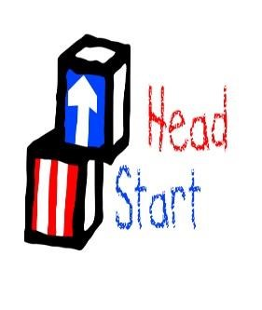

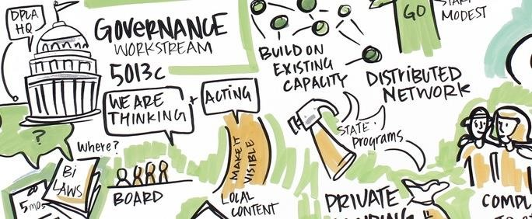

# 5.. PosiPower Head Start Leadership Governance Training - Federal Policy and Guidelines

In this session, Head Start leaders will learn the importance of positive communication, decision making, finding common ground, teamwork, and consensus building.

Components of this course will include the following:

_ The 50 Year History and success of Head Start

_ The mandates and regulations that govern Head Start from top to bottom. _ The legislative policies and regulatory requirements that guide Head Start's daily decision making.

_ The federal guidelines for masking and Covid vaccinations are covered in the training.

_ Why Policy Council Training is mandatory, and parent involvement is essential for the future of Head Start

_ The governing body/Tribal Council, Policy Council, and Management Staff are vital components of Head Start. Each of them has rights and policies and they must work together. Participants will learn to value, cooperate, and how to integrate these components. This is all positive and is initiative-taking governance.

# 6. Be a PosiTeacher in Your Classroom

PosiTeachers give their best and they receive more cooperation from their students, because they give and demand respect. These teachers possess the skills to build cohesiveness among their students by enhancing a positive environment. **Be a PosiTeacher in Your Classroom** is a highly interactive workshop that involves self assessment exercises and group activities. Teachers learn tips on how to change negative child behavior into positive ones. These PosiTeachers learn to role-model appropriate ways to handle negative situations inside and outside the classroom. **Be a PosiTeacher: By Thinking Positively** booklets are available for an additional charge. Main Topics include:

* Maintain a positive self-image and feel good about YOU as a teacher.
* Turn negative classroom situations into positive ones.
* Set an example and role-model appropriate behavior for children/students.
* PosiTeachers are most effective when they are competent with curriculum.
* **Learn how to bring out the best in each student.**
* **10 Principles of a PosiTeacher**

# 7. What to Do When Little Kids Won’t Listen – Classroom Management Skills

One of the most difficult challenges teachers is when a child refuses to listen or follow directions. Quickly an entire classroom or lesson plan is in danger of being derailed. It is during these times that teacher’s patience, skills, and tolerance are tested. In this course, teachers learn positive and effective ways to manage difficult children. They learn why it is important to role model and set examples of ways to manage frustration, anger, and stress. Teachers learn positive ways to provide consequences and why labeling, ridiculing, and isolating can be detrimental to a child's self-esteem and their own. Teachers learn how to talk so children will listen, and strategies to use when they won't. This course is designed to be highly interactive with discussions of real-life situations. Class objectives include:

* Why PosiTeachers have Positive classrooms.
* Role-modeling a positive self-image.
* Turn negative classroom situations into positive ones.
* How to stay positive when overwhelmed by teaching
* Why do children misbehave?
* What to do when a child gets angry.
* What not to do when you get angry.
* 10 PosiPower Ways to Bring out the BEST in Children
* 10 PosiPower Ways to Get Children to Listen

# 8. 5+5 Ways to Teach Math in Head Start

We can link math to reading, science, cooking, history, travel, and even to planning a birthday party. When educators understand how math and numbers are an everyday part of our lives, they can easily teach math to children. In this course, Head Start teachers will learn some practical and fun ways on how to integrate math throughout their classroom curriculum. The course objective is to share:

* How Head Start teachers can give their students a math advantage
* Why children need to learn to love math
* How to incorporate math throughout the curriculum
* 10 PosiPower Ways to Teach Math in Head Start

# 9. “I Can READ” – Early Learning Literacy –

Research has shown that phonemic awareness is the best predictor of early reading and spelling skills. In this course, early child educators will learn that it is exciting to teach young children how to read and *write.* Kids who comprehend that the spoken language consists of distinct sounds – phonemes and syllables – discover that it is easier for them to learn to read. In this course, educators will learn.

* What early education teachers need to learn about literacy standards?
* How to make reading fun for young children
* Phonological Awareness and other reading readiness terms
* 20 PosiPower Ways to Promote Early Reading Skills

# 10. Help Kids Deal with Anger

It is not OK to hit, kick, spit, or curse others; and it is not OK for children to hurt themselves. In many circumstances it is appropriate to teach a child that their feelings of anger are justified. What educators can do as well is teach children appropriate ways to manage angry feelings. So, what can a young kid do when they’re angry? In this course educators will learn:

* Why anger is a normal and healthy reaction.
* How children respond to angry feelings
* Why children need to learn how to cope with angry feelings.
* 10 PosiPower Ways to Teach Children How to Deal With Anger

# 11. Co-Teachers Working Together as a Team

Thistraining is designed specifically for co-teachers in the same classroom. It is essential that they work together positively and effectively. PosiTeachers are role models for their students when they become better team-players. Teachers learn productive ways to cope with classroom conflicts that may hinder their team. Through self-awareness exercises, they also learn how to solve problems by clarifying real issues and roadblocks. They learn how and when to take initiative with difficult students. In this course, co-teachers will support one another by learning the following:

* A positive attitude is best example for their students.
* How to take initiative and how to support one another.
* Ways to promote excellence and increase learning in the classroom.
* Skills that will help resolve interpersonal problems and their causes.
* To resolve or eliminate credibility issues by clarifying real issues and roadblocks that may hinder the team
* 10 PosiPower Tips to Working Together as a Team

# 12. PosiPower Ways to Effectively Work with Parents

Working with parents can be a challenge for even the best teachers. Some parents do not understand or care how they can help teachers to bring out the best in their child. On the other hand, there are some teachers who do not value parents. They see parents who advocate for their child as adversaries rather than part of a team. PosiTeachers understand that working effectively with parents toward a common mission will help ensure the success of the child. In this course, teachers will learn the following components.

* The importance of a positive self-image in the classroom.
* PosiTeacher Techniques for difficult students & their parents.
* Why working positively with parents is the best course of action.
* Ways to get parents involved in school activities.
* How to talks so parents will listen.
* 12 PosiPower Ways to Work Effectively with Parents

# 13. Working in Teams – Teachers, Bus Drivers, Managers, etc…

This training is designed specifically for Head Start team members including administrators, teachers, assistant teachers, case workers, nurses, bus drivers, and other staff. Participants learn how to become better team-players to create the most enriching experience for children. They learn five (5) coaching styles and which ones they prefer or resist. Participants/players learn more productive ways to cope with workplace conflicts that may hinder the team from reaching its goals. Through self-awareness exercises, participants also learn how to solve problems by clarifying genuine issues and roadblocks. They learn how and when to take the initiative. In this course, participants will learn the following:

* A positive attitude is best for the whole team.
* Five (5) Coaching Styles
* How to take initiative and still work within the team.
* Ways to promote excellence and increase productivity.
* Skills that will help resolve interpersonal problems and their causes.
* To resolve or eliminate credibility problems by clarifying real issues and roadblocks that may hinder the team.

# 14. Time and Stress Management for Head Start Teachers and Staff

Teachers today have a lot of demands to meet from students, parents, and administrators. However, it is essential to their mental and physical health, to learn positive ways to manage school related and home stresses. It is also important to learn how to become better organized. Most important, teachers learn how not to pass on stressful habits.

Teachers will benefit from this course because they will learn to manage time and stress. Key points are:

* What's negative & positive about stress.
* Learn constructive ways to use and manage your time in the classroom.
* Let go of destructive worrying, habits, and people.
* 25 Things to do to manage your time better.
* 10 Ways to get rid of negative stressors.
* **10 Ways to feel positive every day.**

# 15. Hire and Retain the Best Teachers

The ability to hire and retain the best staff is a primary goal of all good management. Throughout this course, participants learn how to incorporate education, experience, skills, and interest into a profile that may be used to screen, interview, and place the best applicants. Managers understand the mission of their organization, and the needs and roles of their team members are more effective interviewers. This PosiPower course, like all of our courses, has a self-esteem component because positive-minded managers (PosiManagers) are more likely to take the time and make the effort to ensure that the interview is not just done correctly, but exceptionally. Teachers who feel appreciated, challenged, supported, and encouraged in the workplace are more likely to foster an excellent environment for their students and remain with an organization longer. This course on hiring and retaining the best teachers is dedicated to developing an outstanding work environment where student and parent achievement, and satisfaction are the main objectives. This course will also incorporate components of our popular course for staff,

“It's NOT a Chit-Chat – Interviewing Customers for Effectiveness.” Participants will learn:

* How to properly interview potential teachers.
* What are the characteristics of a positive teacher?
* How to build and enhance people skills.
* The difference between acceptable chit-chat during the interview and sabotaging chit-chat that will derail the interview.
* To promote excellence and increase productivity by getting appropriate responses from teachers and interviewees

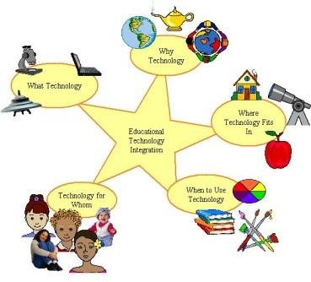

# 16. PosiPower E-Teaching and E-Learning with Technology

From babies to grownups, technology is a part of life and learning, and innovative teaching tools are now accessible by keystrokes. Educators today are learning that it is not enough to genuinely like students and enjoy teaching, they are required to learn effective ways to instruct students who are mesmerized by a technologically influenced world that is becoming almost paperless. It is essential to expose students to information literacy skills that promote math, science, and social studies. As varies teaching strategies are readily available, and information continues to evolve into a paperless format. n this PosiPower course educators are encouraged to bring their laptops. Participants will learn the following:

* Why be positive about technology in the classroom (pros, cons and balance)?

* How to integrate technology into the curriculum.

* Why differentiated teaching styles are effective for challenging and exceptional students.

* How to communicate with parents and students efficiently.

* 20 PosiPower Ways **e-teaching** and **e-learning** through technology is 21st Century and beyond for the classroom

# 17. Coaching the Best Out of Your Teachers and Staff –For Management

Ideal coaches are excited about themselves, their players, and the organization. The purpose of this training is to facilitate administrators and supervisors in creating an encouraging and supportive work environment that thrives on excellence.

Administrators/coaches learn the importance of maintaining a professional and positive self-image and promoting such attributes in their teachers and staff. They discover how to bring out the best in their team, which will allow their teachers and staff to bring out the best in their students. In addition to learning how to motivate teachers and staff to reach their highest potential by uncovering hidden strengths, they learn how to help change negative attitudes into positive ones that minimize conflict and increase productivity. These tools transfer to the classroom. While demonstrating excellent work habits and professional behavior, managers will positively influence teachers and staff during "coaching sessions." The course incorporates team building & leadership skills by highlighting 5 Coaching Styles that encourage communication, cooperation, trust, enthusiasm, and openness. 10 PosiPower techniques to "coach-out" the best in employees are a highlight of the course, along with the following:

* Why Coaches/Supervisors must maintain a positive self-image.
* Identifying the influences of the best and worst coaches in your life
* Working with "problem players"
* Fostering initiative in players
* Developing ways to promote a safe and trusting environment
* Building a great team by developing hidden talents
* Teaching your players to be proud of what they do
* 10 tips to becoming an effective coach

# 18. Celebrate Diversity in Your Classroom - Be inclusive

Diversity is all around us and it is a positive experience that enriches everyone’s life. But to see diversity and not feel included is another matter. Children/students and their families are representatives of all walks of life, and they need to be valued and welcomed into the classroom. In this course teachers learn how to positively respond to students from diverse backgrounds, ethnic groups, races, socio-economic status, as well as ones with different learning styles. They learn why it is important to make connections with each student and to value their uniqueness, and how to include them in the classroom and school community.

* Why it is important to foster a positive learning environment.
* How the classroom is diverse in a variety of ways and how to be inclusive • What is meant by "culture," "diversity," and "race?"
* Why celebrate diversity in your classroom?
* What do all children need?
* 10 tips to help your students to feel **positively** unique.

# 19. Balance Work & Family & Be Positive in Both

The objective of this workshop is to teach teachers the importance of maintaining a balance between work and home life. Teachers learn that educators who have positive interpersonal relationships are the PosiTeachers in their classrooms. They are also Posi Parents if they have children of their own. Teachers with a content home life are more productive in the classroom. They are less distracted by family problems and have fewer absences. These valued teachers can fully focus on their students. In addition, school administrators who value families have loyal teachers. Administrators and teachers working together will find that the benefits are mutually satisfying. In this workshop teachers will discover:

* The benefits of a positive self-image
* That balancing work & family will reduce stress.
* Having a positive attitude for work and family isideal.
* That PosiTeachers have PosiKids in the classroom and at home.
* That teachers can reach their highest goals and still have a loving home.
* How to become a super asset, and not a liability to your workplace or family
* **15 PosiPower Ways to Balance Work & Family**

# 20. Head Start Teachers Model Respect for Diverse Families

When educators think of families today most people envision: dad, mom, two kids, a dog, and maybe a cat. Then they think of a single mom and kids, and grandparents raising grandchildren. There are mixed race couples raising mixed race children; and there are two “Mommies” and two “Daddies” raising children together or as a legally married couple. In all these situations and other family combinations, this is a diverse Head Start family that needs to be valued and supported. In this course, Head Start teachers will learn:

* Why teaching and modeling respect for others is important.

• What is meant by diverse families today?

* What do all children need?
* 10 Positive Ways to help your students to feel **positive** about their family

# 21. Recognizing Physical, Sexual, Emotional Abuse, and Child Neglect – (This course is taught in a 3-part series - Recommended)

All children want to be happy and perform well in school, especially young children.

However, at some point in a child’s life there may be some serious hurdles to a positive future and a need for your intervention. Child abuse is an incredibly sad situation, but it should never be a reason to not do what you can to protect a child. In this course, teachers, childcare providers, and anyone in contact with children will learn the signs of physical, sexual, emotional abuse and neglect, and whom to contact as soon as possible. Topical highlights are:

* 20 Reasons Why PosiTeachers are mandated reporters.
* Signs of physical abuse
* Sign of sexual abuse
* Signs of emotion abuse
* Signs of neglect
* Warning: Triggers of your own past abuse